# Assignment 4

LIU Yangjijing 1155172726

1. **Future user journey map**

1. **Future story map**

1. **Card sorting**

I invited 5 participants to participate in my card sorting, and they also joined the usability test afterward. At first, I set up the "每日推荐" section, originally I wanted to put it under "社区", but I found that participants 1 and 2 were confused about its classification. Also, they showed different sorting logic about “场地交流" and "演出交流", so I modified part of the cards and then let subsequent participants do the sorting.

*Participant 1 and Participant 2*

After the initial adjustments, participants 3 and 4 still had some confusion about “消息中心”, which they both placed under “社区”, where I envisioned that users would indeed receive comments and likes on their posts, but not as a separate sub-navigation. I think it was a problem with the name of the tab, so I changed it to "我的消息".

*Participant 3 and Participant 4*

When I asked the last participant to sort after two changes, the results were largely consistent with what I had envisioned, so I settled on my basic framework。

*Participant 5*

1. **IA sitemap**

When I designed the IA sitemap, I added “场馆入驻” on the basis of the previously collected card sorting, and removed “联系我们" and planned to put it at the bottom navigation bar of the whole page.

1. **Figma prototype**

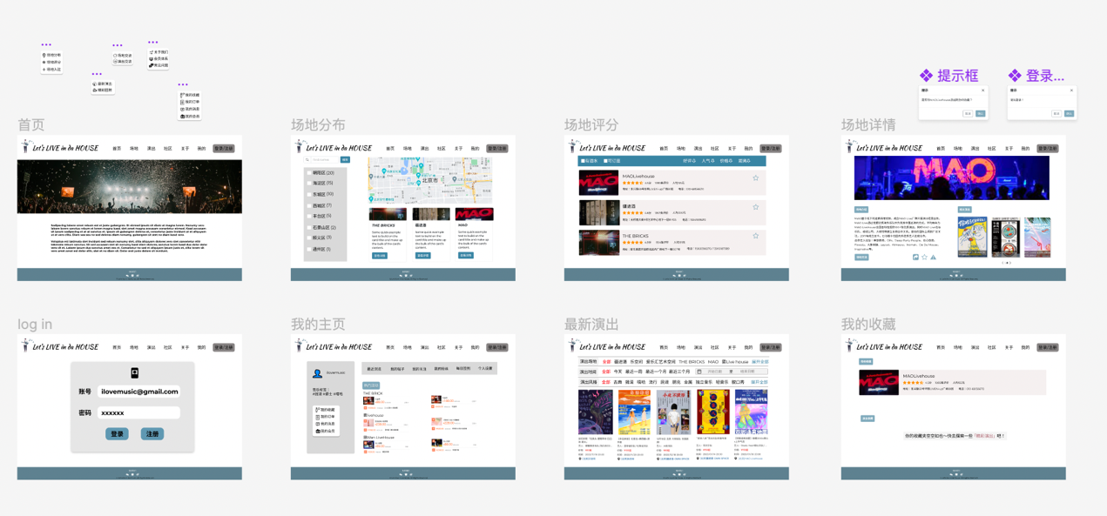

<https://www.figma.com/file/W1NLwfKCYycmpmb64fMEvG/Assignment4?node-id=0%3A1>

<https://www.figma.com/file/lCAYq69Bym1rEcl9j0V91q/%23assignment4?node-id=0%3A1>

1. **Key hypothesis**
2. Users can find multiple paths to the same interface (e.g., find the detailed page of a venue and go to “我的收藏”)
3. Users can understand the logic and relationship between different interfaces.
4. It’s easy and efficient for users to browse the information they need on the website.
5. Users won’t feel it annoying when the alert boxes appear, for example when they are going to bookmark a certain venue, there will be a tip reminding them to log in first.
6. The website is user-friendly and will be helpful for my persona.
7. **Usability planning dashboard**

表格

1. **Usability test analysis**

Please see another PDF file.